**Project 2 - Create a report using Power Query, Macro VBA, List Functions and Data Validation functions for Data Reporting of Supply Chain Management companies.**

Features of Dashboard

* Gender Ratio of Applicants
* Car Owner/ Non-Owner Ratio
* House Owner/ Non-Owner Ratio
* Client Income Type
* Client’s Level of Education
* Client’s Housing Type
* Client’s Family Status
* Client’s Occupation Type

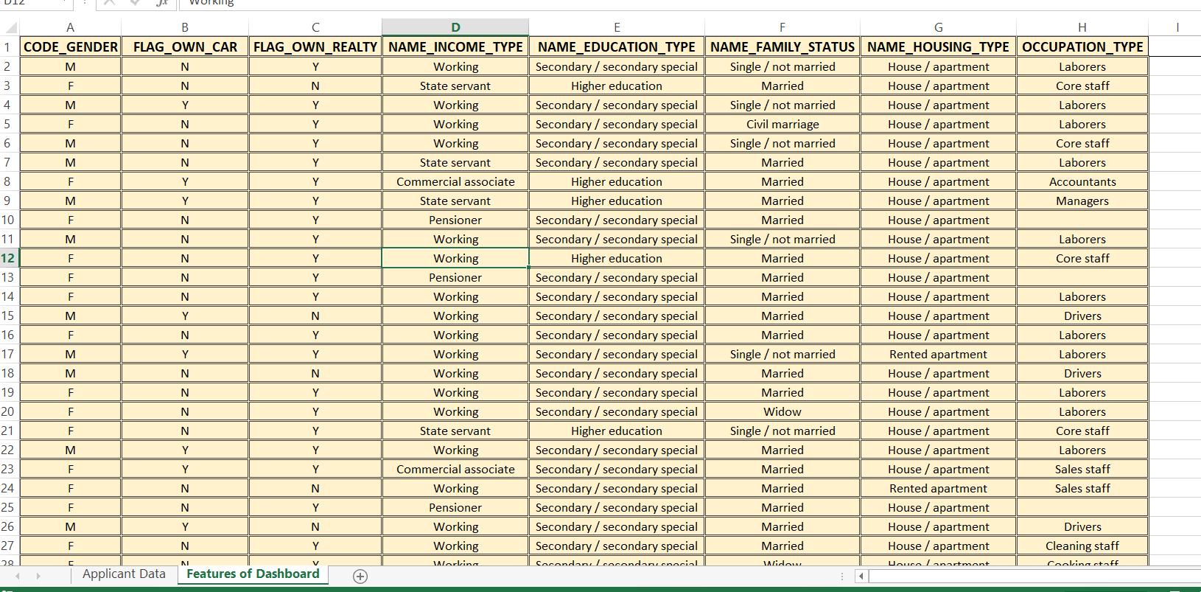

Data Summary of All Female Client’s for Income and Loan Amount using New Functions.

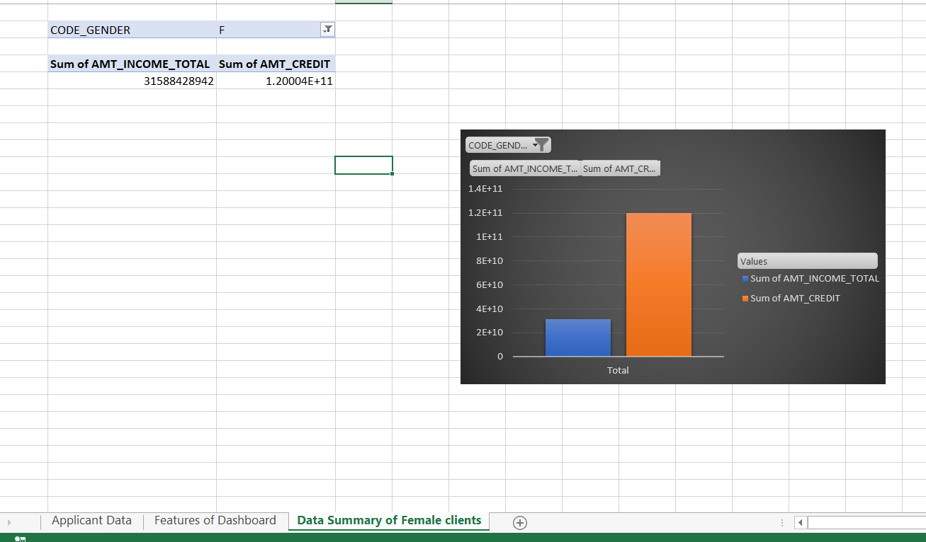

Data Summary of All Male Client’s for Income and Loan Amount using List Functions

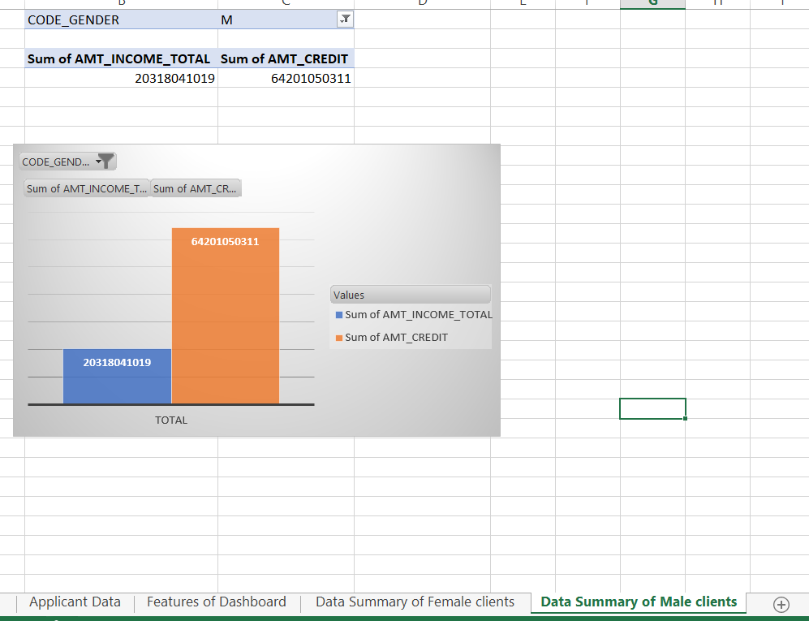

Data Summary for all Flag Columns like (FLAG_DOCUMENT_2, FLAG_DOCUMENT_3 etc.) using all variants of DCOUNT function.

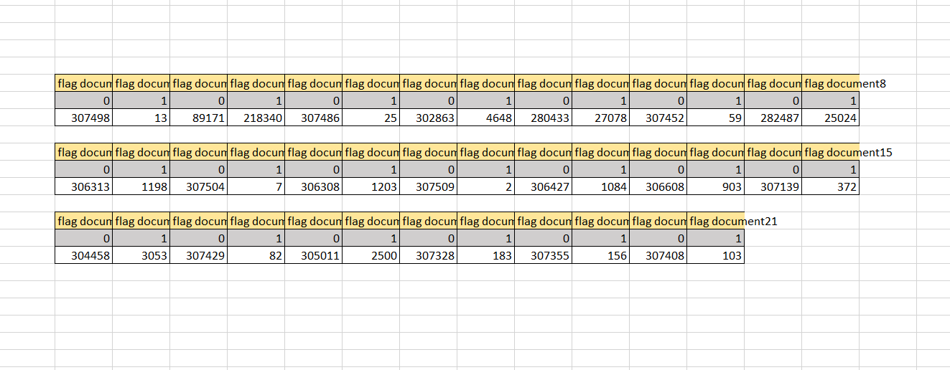

Create a Macro for Data Formatting (Conditional Formatting, Freezing Panes) of workbook as same will be applied to the data of next quarter

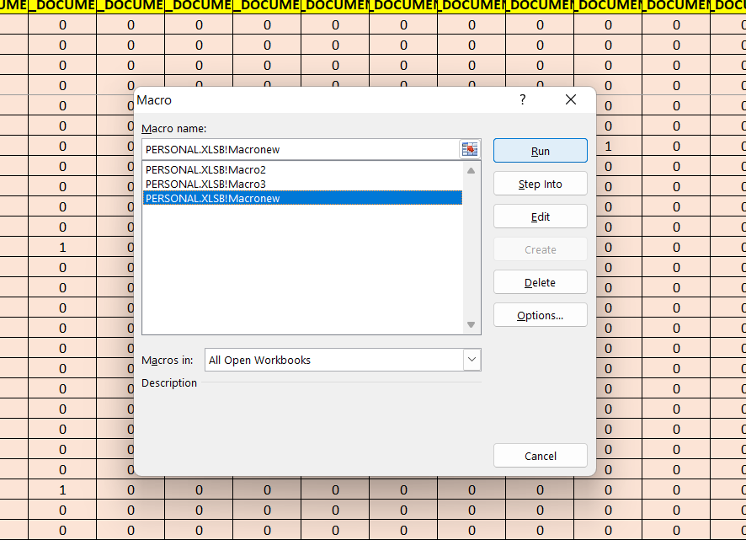

Create VBA code to convert selected data into pdf from application data.

Sub ToPDE()

Dim wb As Workbook

Dim ws As Worksheet

Dim rng As Range

Dim FName As String

Set wb = ThisWorkbook

Set ws = wb. Worksheets ("Report Output")

Set rng = W.Range ("D3: J19")

FName = ws.Range ("M5") .Value & " " & Format (Now(),"MM-DD-YYYY") & ".pdf"

rng. ExportAsFixedFormat _

Type: =x1TypePDF, _

Filename : =Path & FName, _

IgnorePrintAreas:=True

Check spelling mistakes in the workbook using VBA code.

Sub highlightspellingmistake()

Dim rng As Range

For Each rng In ActiveSheet.UsedRange

If Not Application.CheckSpelling (word: =rng.Text) Then

rng. Style="Bad"

End If

Next rng

End Sub

